|  |  |
| --- | --- |
| Name: |  |
| Class: |  |

http://www.misteraidan. com/

**Part A: Read.**



**Saint Valentine’s Day is on the 14th of February.**

**People all around the world write cards for their boyfriends or girlfriends on this day. Lots of people buy flowers and other gifts on St. Valentines Day.**

**But why do we have this day? Who was the first Valentine? This is the story of Saint Valentine.**



About 1700 years ago there was a man called Valentine.

He was a priest. He liked to see young people in love.

He wanted people to get married because he wanted them to have a family.

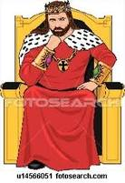

But the Emperor Claudius didn’t want men to get married.

He wanted men to fight in the army.

He wanted more soldiers.



Valentine didn’t agree.

He helped men and women to get married in secret.

Emperor Claudius didn’t know about this.

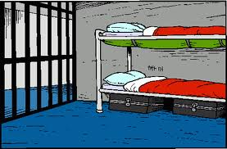

When Claudius heard the story of Valentine, he was

very angry. He put Valentine in jail for 20 years.



After twenty years, Claudius killed Valentine on February 14th.

Everybody thought Valentine was a good man because he helped lovers. That’s why we have St. Valentine’s Day every year.

**Part B: True or False.**

|  |
| --- |
|  |

1. Valentine was an emperor.

|  |
| --- |
|  |

2. Valentine died on February 14th.

|  |
| --- |
|  |

3. Claudius wanted men to get married.

|  |
| --- |
|  |

4. Claudius put Valentine in jail.

|  |
| --- |
|  |

5. Valentine was in jail for forty years.

|  |
| --- |
|  |

6. Valentine helped people to get married.

**Part C: Answer Yes or No.**

|  |
| --- |
|  |

1. Was Valentine a priest?

|  |
| --- |
|  |

2. Did Claudius want people to get married?

|  |
| --- |
|  |

3. Did Claudius want women to be soldiers?

|  |
| --- |
|  |

4. Did Claudius put Valentine in jail?

|  |
| --- |
|  |

5. Was Valentine an emperor?

|  |
| --- |
|  |

6. Did Valentine help people to be soldiers?

**Part D: Answer the questions. (Write full sentences please.)**

1. Why did Valentine want people to get married?

|  |
| --- |
|  |

2. When did Valentine live?

|  |
| --- |
|  |

3. What did Valentine help people to do?

|  |
| --- |
|  |

**Part E: Now write three things about Valentine’s Day in your country.**

|  |
| --- |
|  |

|  |
| --- |
|  |

|  |
| --- |
|  |