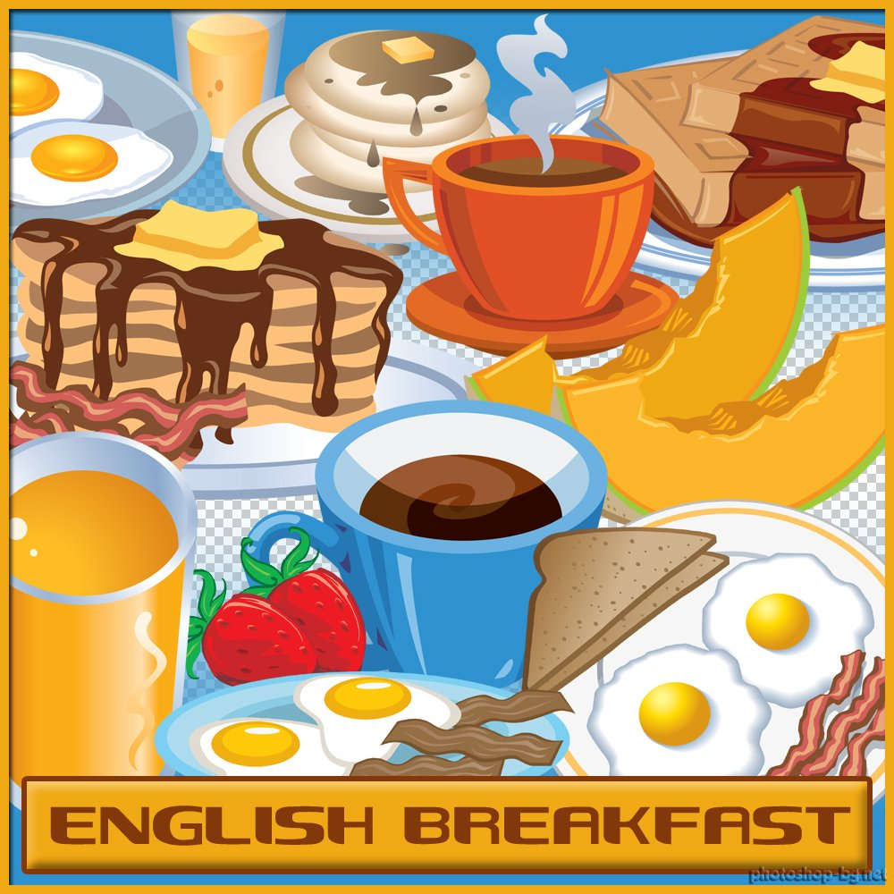
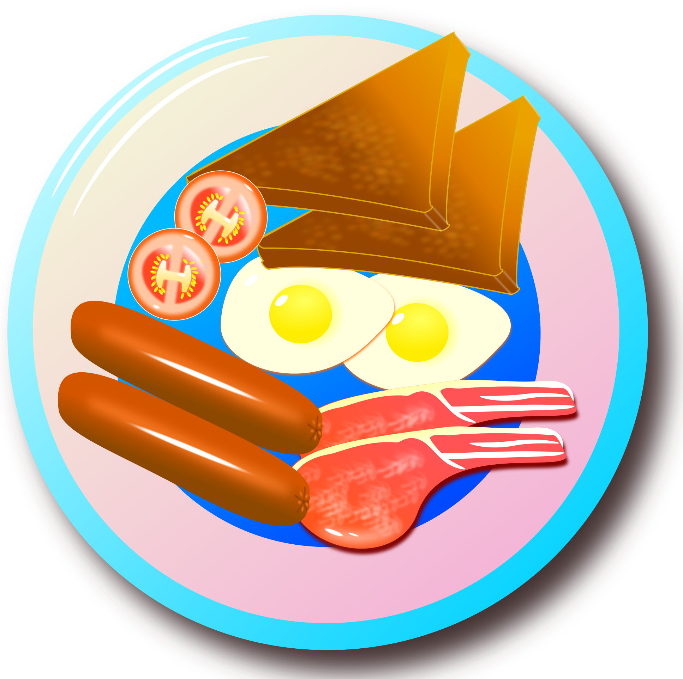
A. Read and complete the text using the words from the box.

Breakfast preferences
Serena – Good morning, Jane! Ready for the Chemistry test?
Jane – Good morning! Yes, I'm ready. I had a good night's sleep and a wonderful breakfast, so I'm full of (1) ___________________!
Serena – So am I! I can't imagine myself (2) ___________________ breakfast! I usually have cereal with milk, a glass of orange juice and, if I have the (3) ___________________, some fruit.
Jane – I know what you mean! Breakfast is the most important and delicious (4) ___________________ of the day. At least for me!
Serena – Me too! When I wake up later at weekends, I love to have a real (5) ___________________ breakfast. The hardest part is (6) ___________________: delicious bacon and eggs, fried sausages, toasts, baked beans or fried tomatoes… And of course, some orange juice or a cup of tea with milk!
Jane – Is it? At weekends, I‘m more into a (7) ___________________ breakfast… A cup of tea, a glass of juice or milk, some (8) ___________________ or croissants with jam, (9) ___________________ or ham really make my day!
Serena – Oh Jane! The bell is ringing; let's go to class before I start getting (10) ___________________ again!
Jane – You're right! Good luck on your test!

● choosing
● cheese
● energy
● sweet
● time
● hungry
● English
● skipping
● bread
● meal

B. Label the picture with the help of the text. Some of the words are not in the text.

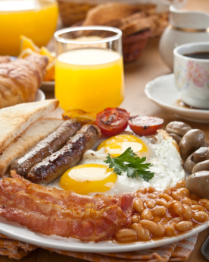

C. Now write about your breakfast preferences – say what you like/don’t like eating.

________________________________________________________________________________________________________________________________________________________________________________________________________________________________________________________________________

