Look at the picture and complete the sentence, then colour Mr. Bunny following the code and the Easter eggs as you want.

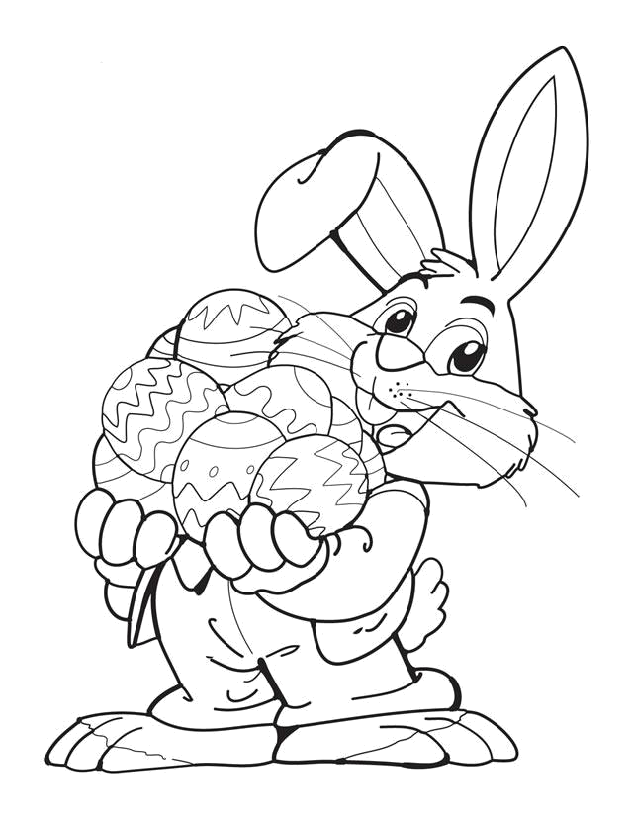
Hello! I’m
E _____ B ____
4
4
9
8
9
9
9
9
9
9
9
6
2
5
5
6
9
1
9
9
9
9
9
8
2
8
3

3

9

