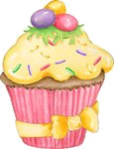
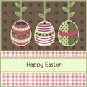
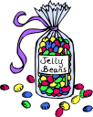
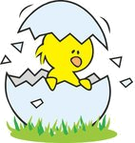
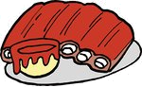
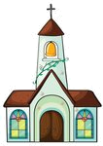
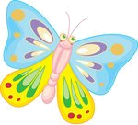
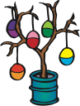
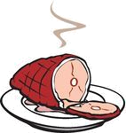
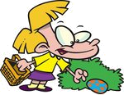
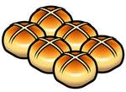
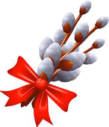
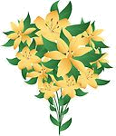


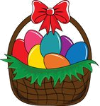
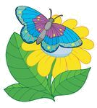
EASTER TIME
Find twelve Easter words in the word search.

JALBNRUMIBEGGHUNTINGLABONNETORLCARDRNNCAYHSLILYYHSBICATEIOUSECVMPGFTRAAKCBLGEGCUNNJIOSPDHASIGREETING
Put the letters in the correct order.

1 lraip: _________________
2 eirtggen:_________________
3 utomces:_________________
4 ntoebn:_________________
5 citnak:_________________
6 agsrs:_________________
7 nooeirctda:_________________
8 hccrhu:_________________
9 taarcseeek:_________________
10 ghgtneuing:_________________
Match the words and the pictures.
1 Easter card 2 egg hunting 3 church 4 catkin 5 hot cross buns
6 Easter cupcake 7 ham 8 jelly beans 9 spring 10 roasted lamb
11 greeting 12 chick 13 butterfly 14 lily 15 egg tree
Find the odd one out.

1 bunny – lamb – reindeer - chick
2 butterfly – bunny – ladybug - bee
3 egg – sprout – catkin - tree
4 egg hunting – egg painting – egg rolling – egg eating
5 ham – egg – turkey - lamb
6 tulip – ladybug – daffodil - lily

Find the Easter words in the circle.
eggpaintingdaffodilgoodfridayeastersundayspringhotcrossbunholybiblesproutroastedlambeastercakedecorationchocolateeggbeecatkinbow
What are they?

1 A small round cake or piece of bread: ________________
2 A Sunday in March or April, and the days around it, when Christians think about coming back to life: ______________
3 The part of the year after winter when plants start to grow: _________________
4 The Friday before Easter when Christians remember the death of Christ: __________________
5 Meat from a pig’s leg that you can keep for a long time because salt or smoke was used to prepare it: ___________

spring ham Easter bun Good Friday

KEY
Find twelve Easter words in the word search.

JALBNRUMIBEGGHUNTINGLABONNETORLCARDRNNCAYHSLILYYHSBICATEIOUSECVMPGFTRAAKCBLGEGCUNNJIOSPDHASIGREETING
Put the letters in the correct order.

1 lraip: April
2 eirtggen:greeting
3 utomces:costume
4 ntoebn:bonnet
5 citnak:catkin
6 agsrs:grass
7 nooeirctda:decoration
8 hccrhu:church
9 taarcseeek:Easter cake
10 ghgtneuing:egg hunting
Match the words and the pictures.
1 Easter card 2 egg hunting 3 church 4 catkin 5 hot cross buns
6 Easter cupcake 7 ham 8 jelly beans 9 spring 10 roasted lamb
11 greeting 12 chick 13 butterfly 14 lily 15 egg tree
6
1
8
12
10
3
13
15
7
2
5
4
14
11
9
Find the odd one out.

1 bunny – lamb – reindeer - chick
2 butterfly – bunny – ladybug - bee
3 egg – sprout – catkin - tree
4 egg hunting – egg painting – egg rolling – egg eating
5 ham – egg – turkey - lamb
6 tulip – ladybug – daffodil - lily

What are they?

1 A small round cake or piece of bread: bun
2 A Sunday in March or April, and the days around it, when Christians think about coming back to life: Easter
3 The part of the year after winter when plants start to grow: spring
4 The Friday before Easter when Christians remember the death of Christ: Good Friday
5 Meat from a pig’s leg that you can keep for a long time because salt or smoke was used to prepare it: ham

spring ham Easter bun Good Friday
egg painting, daffodil, Good Friday, Easter Sunday, spring, hot cross bun, Holy Bible, sprout, roasted lamb, Easter cake, decoration, chocolate egg, bee, catkin, bow

