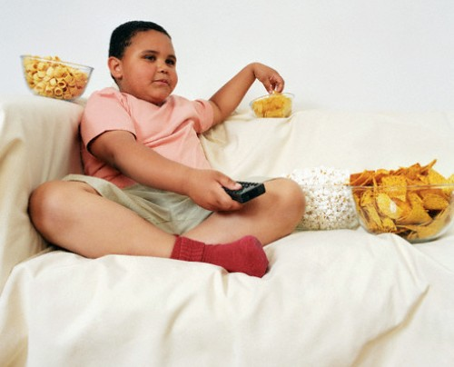

This is Rob, he is 10 years old and from America. He likes to sit on the sofa for four hours every day, watching TV and eating lots of snacks.

- What’s the matter with Rob?
- What is Rob doing in the picture?
- Where is Rob?
- What should Rob stop doing to be healthy?
- What should Rob start doing to be healthy?
- What advice would you give to Rob?
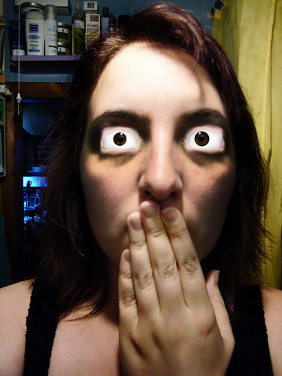
This is Adele, she is 12 years old and from Italy. She likes to watch TV for 5 hours every day and then play computer games for 2 hours. Her eyes hurt all the time.

- What’s the matter with Adele?
- What is Adele doing in the picture?
- Where is Adele?
- What should Adele stop doing to be healthy?
- What should Adele start doing to be healthy?
- What advice would you give to Adele?


This is Emma, she is 17 years old and from Canada. She smokes at least five cigarettes every day. She has a cough and a sore throat.

- What’s the matter with Emma?
- What is Emma doing in the picture?
- Where is Emma?
- What should Emma stop doing to be healthy?
- What should Emma start doing to be healthy?
- What advice would you give to Emma?

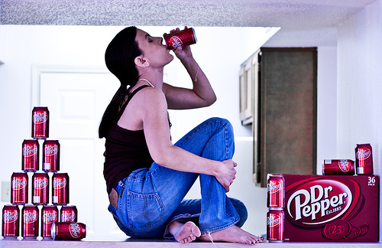
This is Ami, she is 13 years old and from Japan. She drinks at least three cans of soda every day. She feels sick and is starting to put on a lot of weight.

- What’s the matter with Ami?
- What is Ami doing in the picture?
- Where is Ami?
- What should Ami stop doing to be healthy?
- What should Ami start doing to be healthy?
- What advice would you give to Ami?



This is Fred, he is 9 years old and from China. He likes to eat fast food every day. His favourite fast food restaurant is McDonalds.

- What’s the matter with Fred?
- What is Fred doing in the picture?
- Where is Fred?
- What should Fred stop doing to be healthy?
- What should Fred start doing to be healthy?
- What advice would you give to Fred?


This is John, he is 11 years old and from Russia. He sleeps for five hours every night. He goes to bed at midnight and gets up at 5am. He always feels tired and falls asleep at school and on the bus home.

- What’s the matter with John?
- What is John doing in the picture?
- Where is John?
- What should John stop doing to be healthy?
- What should John start doing to be healthy?
- What advice would you give to John?

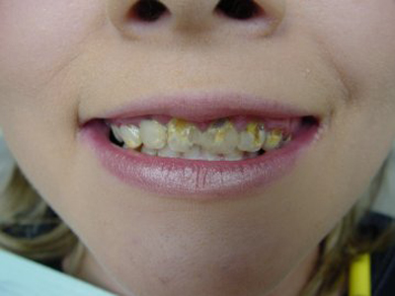

This is Melissa, she is 11 years old and from the USA. She likes to eat sweets and chocolate every day, her favourite chocolate is Meiji strawberry chocolate. She brushes her teeth once a day before she goes to bed.

- What’s the matter with Melissa?
- What is Melissa doing in the picture?
- Where is Melissa?
- What should Melissa stop doing to be healthy?
- What should Melissa start doing to be healthy?
- What advice would you give to Melissa?

