HOW TO MAKE PANCAKES

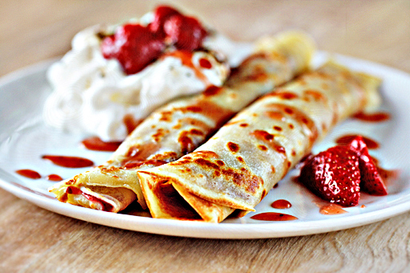 | http://www.youtube.com/watch?v=ayIuoNCaD7I

- What do I need?

I need …

some butter / some yeast / a whisk / some salt / a bowl /
½ a litre of milk / a frying pan / 500 gr of flour / 4 eggs

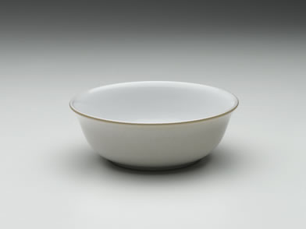
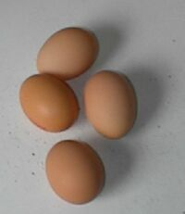
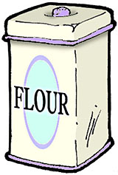

1) ………………………  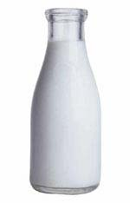 | 2) ……………………… | 3) ………………………
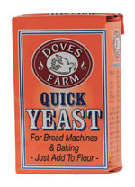
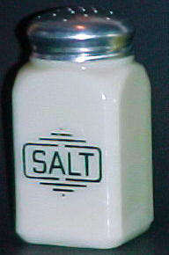

4) ……………………… | 5) ……………………… | 6) ………………………
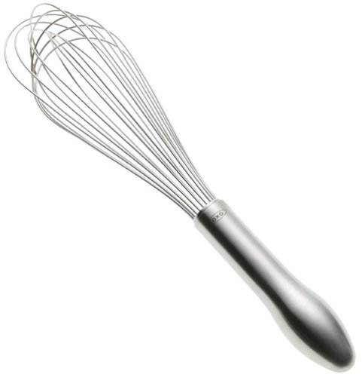
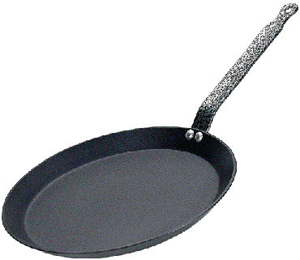
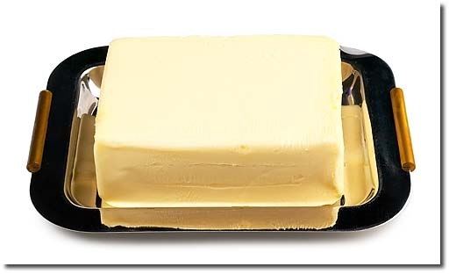

7) ……………………… | 8) ……………………… | 9) ………………………

2) Instructions
take / put / break / add (x3) / mix / cook / use

(1) First ………………………….. a bowl

(2) Next, ……………………… 250 grams of flour into the bowl.
(3) Then, ………………. 4 eggs into the bowl,
(4) and ………………… ½ litre of milk into the bowl.
(5) Then, ……………………… some yeast to the flour,
(6) and ………………….. a pinch of salt.
(7) Next, …………………… with a whisk.
(8) …………………… some butter for cooking.
(9) Finally, …………………… the pancakes in a frying pan.

