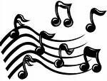
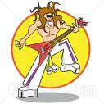
Let’s talk about MUSIC

Conversation cards
What’s your favourite kind of music?
How often do you listen to music?
Can you play a musical instrument?
If so, which one?
Have you ever been to a concert or live show?
Talk about it.
Do you like to sing?
Why (not)?
Have you ever sung karaoke?
Did you like it?
How many CDs do you have? What’s your favourite?
Have you ever downloaded music from the Internet?
Why?
Do you have an MP3-player?
How often do you use it?
Do you prefer music in English or in your own language? Why?
Do you ever listen to loud music? When?
Which musician or band would you most like to meet? Why?
Can you dance?
What’s your favourite dance?
When you listen to music, do you try to understand the words (lyrics)?
Do you listen to music on the radio? What’s your favourite radio station?
Would you like to be a famous singer? Why?
What’s your favourite band? Why do you like it?

What’s your favourite singer? Why do you like him or her?

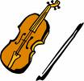
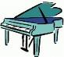
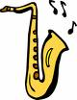
Tick the music you like
classical
easy listening
heavy metal
hip hop
jazz
R&B
rap
rock
salsa
traditional

1
2
3
4
5
6
7
8
9
10
11
12
Match instruments and pictures
accordion |  | piano
drums |  | saxophone
flute |  | tambourine
guitar |  | triangle
harmonica |  | trumpet
organ |  | violin

