**My Pet**

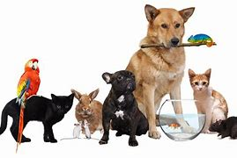

My favourite pet is a (an) ……………………………………………….………............................

I have a (an) ………………………………………………………………………..……………… at home.

Its name is ………………………………………………………………………………………………………..

It has ………………………………………………………………………………………….……... colour(s).

It likes ………………………………………………………………………………………………………………..

It eats ……………………………………………………………………………………………………………….

This is a picture of my pet: