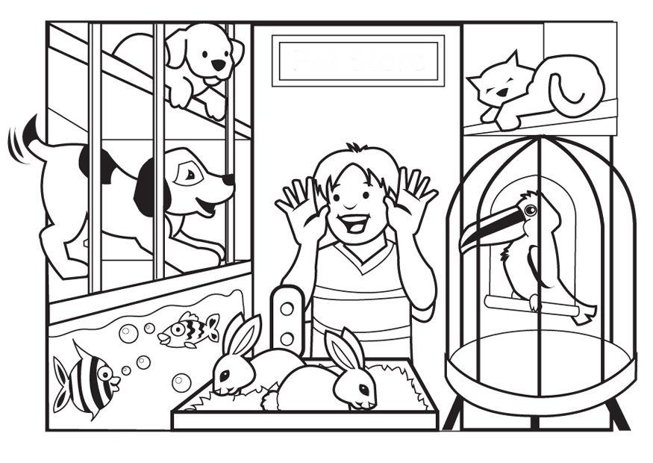PETS

PAINT…

* ONE DOG BROWN
* ONE DOG YELLOW
* ONE FISH RED
* ONE FISH PURPLE
* THE RABBITS BLACK
* THE PARROT GREEN
* THE CAT PINK