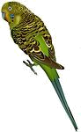
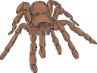
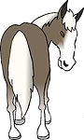
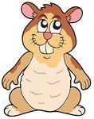
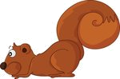
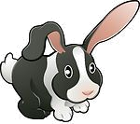
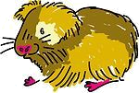
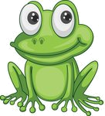

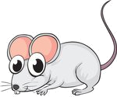
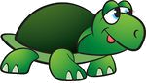
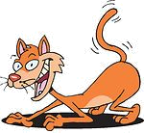

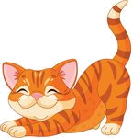
OUR LITTLE FRIENDS (PETS)
Find ten pets in the word search.

SDIUHESAQNLKEURQUCATDRATISDKGMBHRFNIEPBORFISHDIRELFROGTSLADOGVTE
Put the letters in the correct order.

1 grfo: _________________
2 ibrtab:_________________
3 pppuy:_________________
4 asenk:_________________
5 debgui:_________________
6 osher: ________________
7 tuetlr: ________________
8 sodighlf:_________________
9 dprsie:_________________
10 nuaggiiep: _________________
Match the words and the pictures.
1 budgie
2 frog
3 cat
4 horse
5 guinea pig
6 white mouse
7 tarantula
8 rabbit
9 dog
10 hamster
11 turtle
12 squirrel

Find the odd one out.

1 canary – budgie – pony - parrot
2 squirrel – turtle – frog - snake
3 mouse – goldfish – white mouse - rat
4 squirrel – guinea pig – hamster - frog
5 puppy – tarantula – kitten - pony

Find the pets in the circle.
catguineapigtortoisehorsecanaryhedgehograbbitsnakesquirrelparrotspiderfrog
What are they?

1 A small animal with long ears: _____________
2 A young cat: ______________
3 A small animal covered with hairs that are like sharp needles: _______________
4 A small animal that lives in and near water and has long back legs and can jump: ________
5 A bird with very bright feathers that can copy what people say: ____________
6 A small animal that can keep food in the sides of its mouth: _______________
hedgehog hamster parrot rabbit kitten frog

