shapes

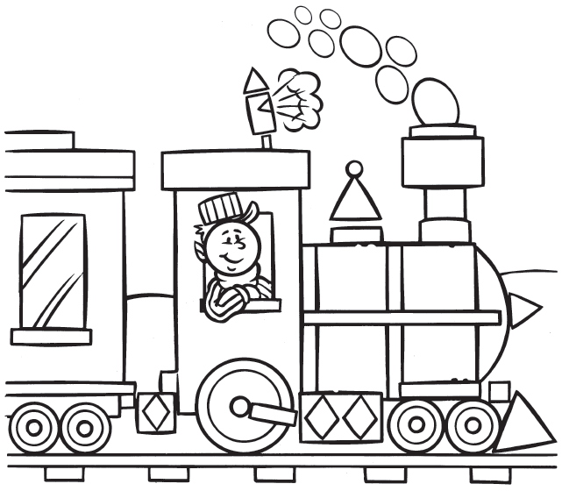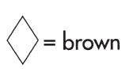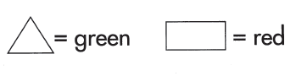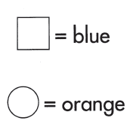**My name is: ___________________________________________**