
1
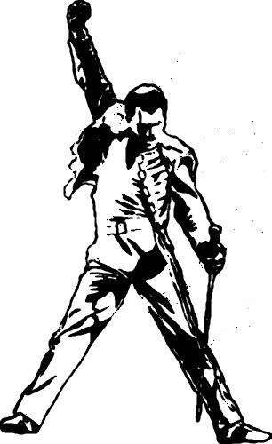

2
3
Rewrite the following words in rhyming pairs. (Two of them do not strictly rhyme but have the same vowel sound)

aching bill breaking(X2) die butterflies chance corner crime flaking for grin in overkill pantomime places romance score spaces warmer

…………………………….. ……………………………..
…………………………….. ……………………………..
…………………………….. ……………………………..
…………………………….. ……………………………..
…………………………….. ……………………………..
…………………………….. ……………………………..
…………………………….. ……………………………..
…………………………….. ……………………………..
…………………………….. ……………………………..
…………………………….. ……………………………..

Complete the lyrics with the words from exercise 1.

Empty …………………… - what are we living …………………………
Abandoned …………………… - I guess we know the ……………………
On and on
Does anybody know what we are looking for?

Another hero - another mindless …………………………
Behind the curtain, in the …………………………
Hold the line
Does anybody want to take it anymore?

The show must go on
The show must go on
Inside my heart is …………………………
My make-up may be …………………………
But my smile still stays on

Whatever happens, I’ll leave it all to …………………………
Another heartache - another failed …………………………
On and on
Does anybody know what we are living for?
I guess I’m learning
I must be ………………………… now
I’ll soon be turning round the ………………………… now
Outside the dawn is …………………………
But inside in the dark I’m ………………………… to be free

The show must go on
The show must go on, yeah
Ooh, inside my heart is …………………………
My make-up may be …………………………
But my smile still stays on
Yeah oh oh oh

My soul is painted like the wings of …………………………
Fairy tales of yesterday will grow but never …………………………
I can fly, my friends

The show must go on, yeah
The show must go on
I’ll face it with a …………………………
I’m never giving …………………………
On with the show

I’ll top the …………………………
I’ll …………………………
I have to find the will to carry on
On with the show
On with the show

The show must go on...

Find the words or expressions in the lyrics which have a similar meaning to the following.

- a big smile …………………………
- accepting that you cannot win …………………………
- be the most important actor in the show …………………………
- completely stupid …………………………
- empty, deserted …………………………
- falling off in small thin pieces …………………………
- accept a difficult situation and try to deal with it …………………………
- having a strong desire …………………………
- know the real facts of a situation, esp. the unpleasant ones (realize the difficulties of life) …………………………
- morning light is just beginning to appear …………………………

"The Show Must Go On", written primarily by Brian May, chronicles the effort of Freddie Mercury continuing to perform despite approaching the end of his life. It was released as a single just six weeks before Mercury died of bronchopneumonia, a complication of AIDS (November 1991). Due to Mercury's deteriorating health at the time, the video is mainly just clips of old Queen videos and a few live performances, but it is so cleverly edited and spliced together that it works as a video of its own.
[adapted from Wikipedia]

