**Numbers: 1-20**

1. Decode the words:

|  |  |  |  |  |  |  |  |  |  |  |  |  |  |  |  |  |  |  |  |  |  |  |  |  |  |
| --- | --- | --- | --- | --- | --- | --- | --- | --- | --- | --- | --- | --- | --- | --- | --- | --- | --- | --- | --- | --- | --- | --- | --- | --- | --- |
| A | B | C | D | E | F | G | H | I | J | K | L | M | N | O | P | Q | R | S | T | U | V | W | X | Y | Z |
| ZAA Z | Y | X | W | V | U | T | S | R | Q | P | O | N | M | L | K | J | I | H | G | F | E | D | C | B | A |

e.g LMV – ONE

a. GDL – …………….. k. GDVOEV -…………….

b. GSIVV –…………… l. GSRIGVVM -……………

c. ULFI –……………. m. ULFIGVVM -…………….

d. UREV –………….. n. URUGVVM -……………

e. HRC –……….. o. HRCGVVM -……………

f. HVEVM –………….. p. HVEVMGVVM-…………

g. VRTSG –…………. q. VRTSGVVM -……………

h. MRMV –………….. r. MRMVGVVM -………….

i. GVM –………….. s. GDVMGB -…………

j. VOVEVM –…………

1. Do the math and write according to the model:

e.g 1+1= 2 →one plus one is two

a. 2+5= …………………………………………………………………………………

b. 13+7=………………………………………………………………………………..

c.12+7=………………………………………………………………………………….

d.6+6=…………………………………………………………………………………..

e.8+2=……………………………………………………………………………………

f. 12+3=…………………………………………………………………………………

g. 9+8=…………………………………………………………………………………..

h. 14+2=…………………………………………………………………………………

i. 9+4=…………………………………………………………………………………….

j. 8+3=……………………………………………………………………………………

1. Match the numbers with the words:

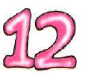 ONE

 NINETEEN

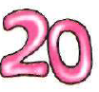 TWO

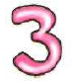 THIRTEEN

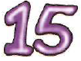 EIGHT

 TWELVE

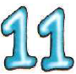 FIFTEEN

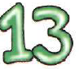 TWENTY

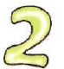 THREE

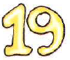 ELEVEN