**THE MAIN ENGLISH SPREAKING COUNTRIES**

**1-Write the name of each country then colour its flag.**

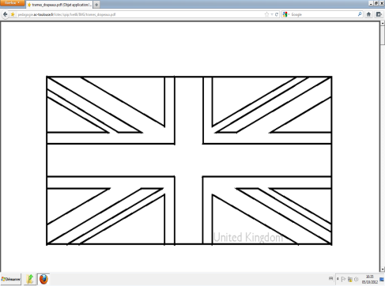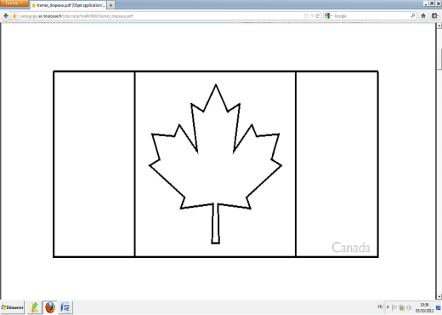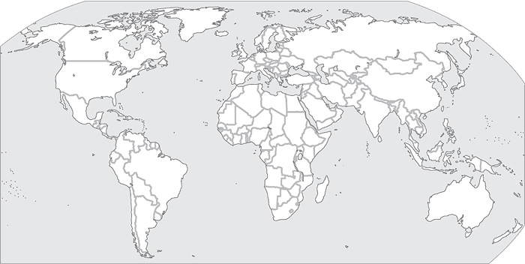

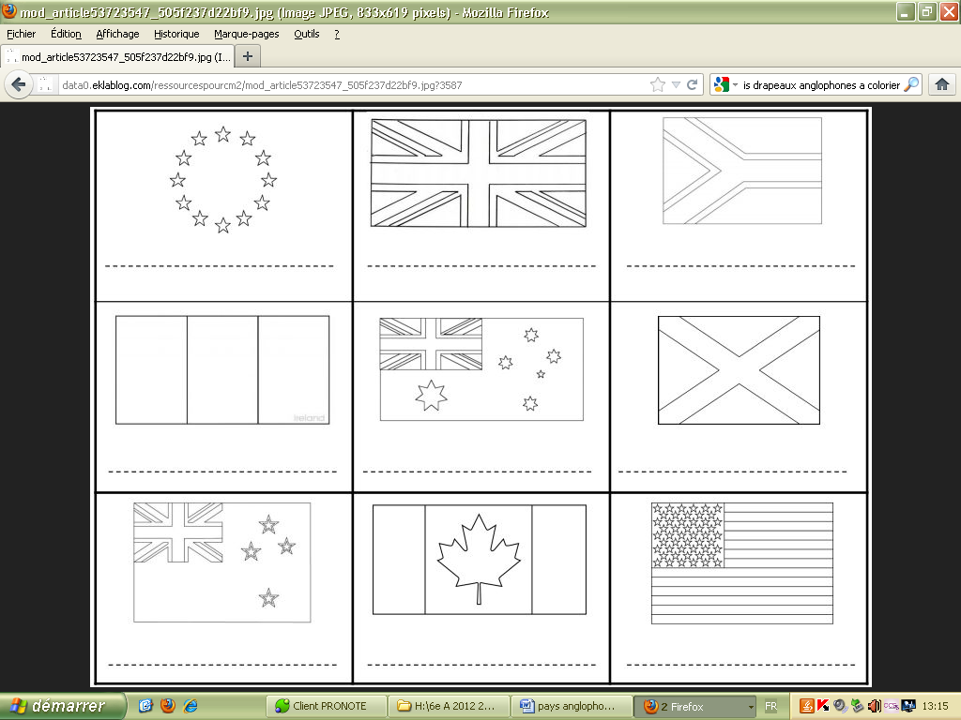

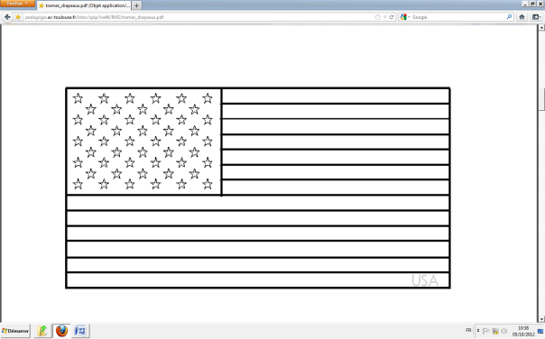

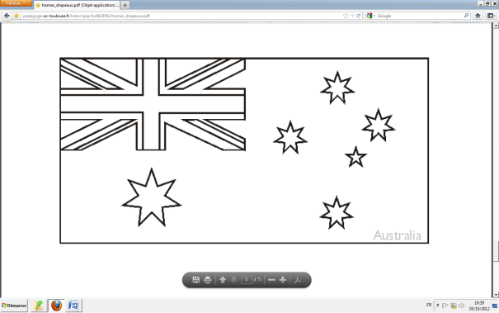

**2- a) Match the flags with the countries and the nationalities**.

|  |  |  |
| --- | --- | --- |
| FLAG | COUNTRY | NATIONALITY |
| C:\Users\Aline\AppData\Local\Microsoft\Windows\Temporary Internet Files\Content.IE5\1BSH4FG4\MP900362706[1].jpg | ⚫The USA | ⚫British |
| C:\Users\Aline\AppData\Local\Microsoft\Windows\Temporary Internet Files\Content.IE5\ZPSSL5HG\MP900362858[1].jpg | ⚫ Great Britain | ⚫American |
| C:\Users\Aline\AppData\Local\Microsoft\Windows\Temporary Internet Files\Content.IE5\FXMMYYRQ\MP900362608[1].jpg | ⚫Canada | ⚫Irish |
| C:\Users\Aline\AppData\Local\Microsoft\Windows\Temporary Internet Files\Content.IE5\FXMMYYRQ\MP900362634[1].jpg | ⚫Ireland | ⚫Australian |
| https://encrypted-tbn3.google.com/images?q=tbn:ANd9GcTjsmH_x50DetXVAWTTcdaiA9HuUn_RBaWmt_u5R2wuA1SA_jL- | ⚫Australia | ⚫Canadian |

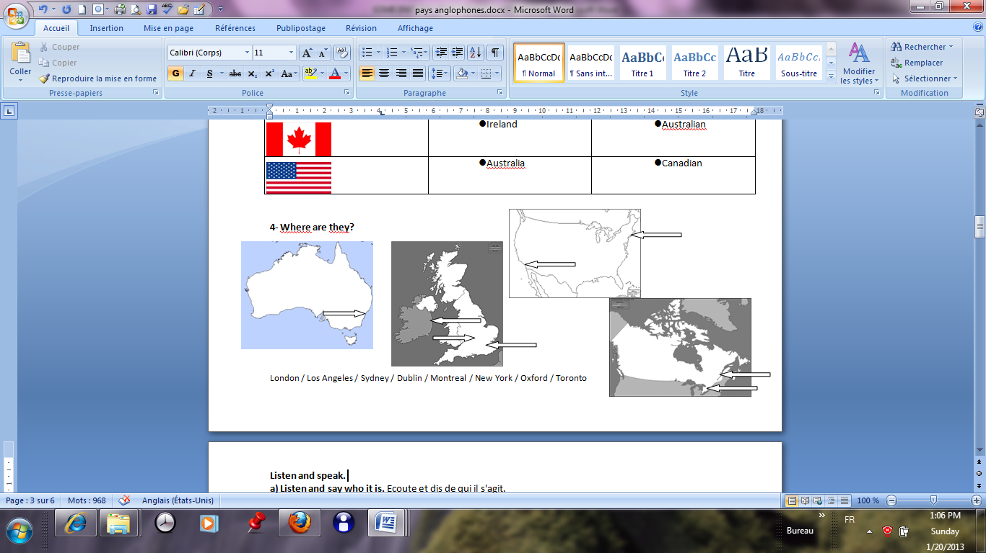**3- Where are they?** Situate these famous cities.