Name:__________________________ Year:______ Class:______ No:______
- Countries and Flags : Match the country with the flag
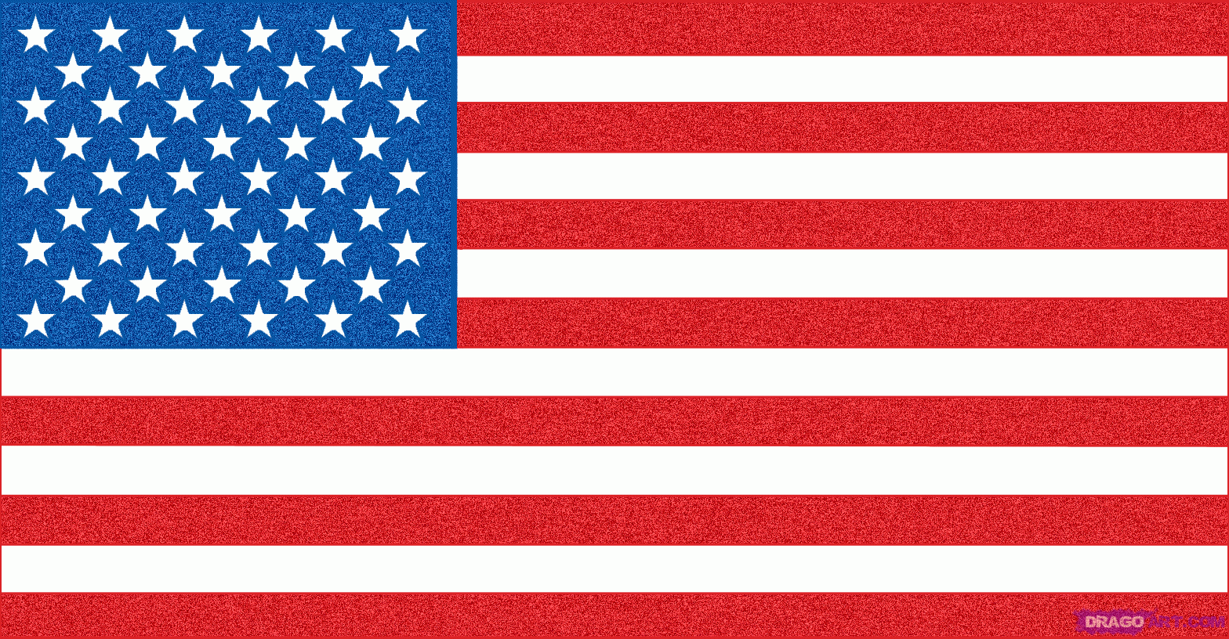 | 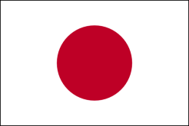 | 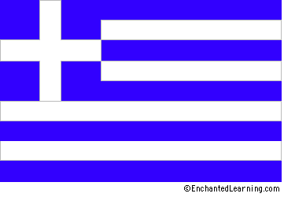 | 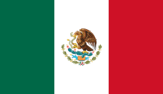 | 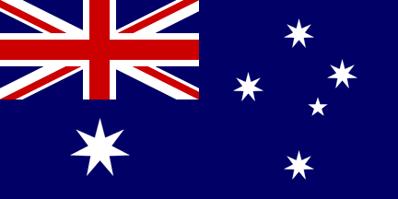
a) | b) | c) | d) | e)
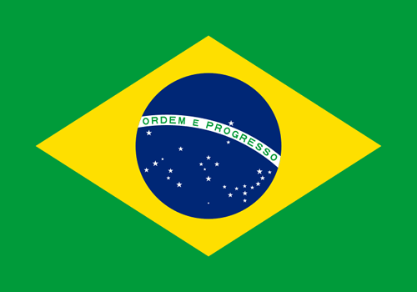 | 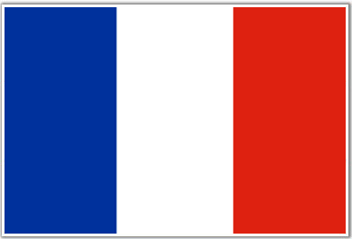 | 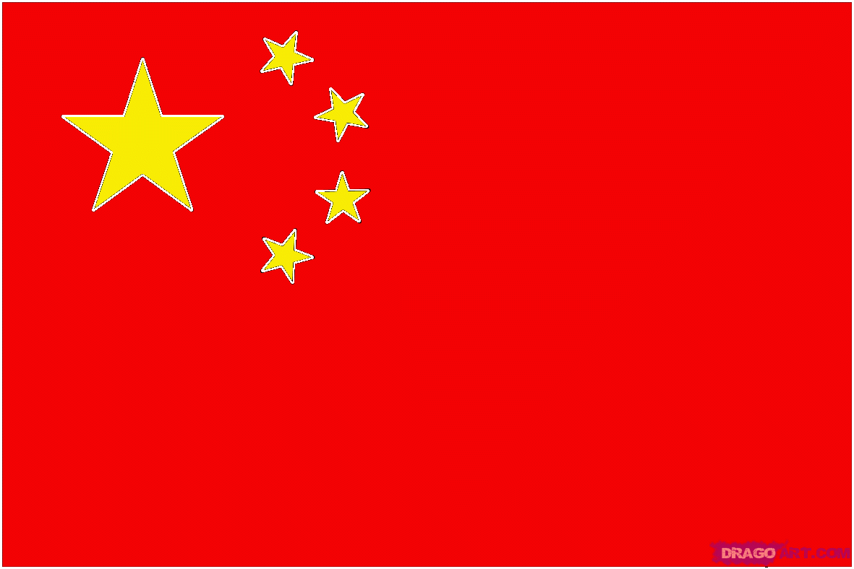 | 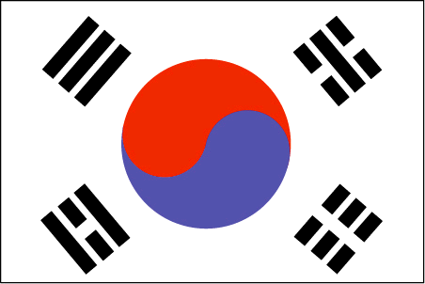 | 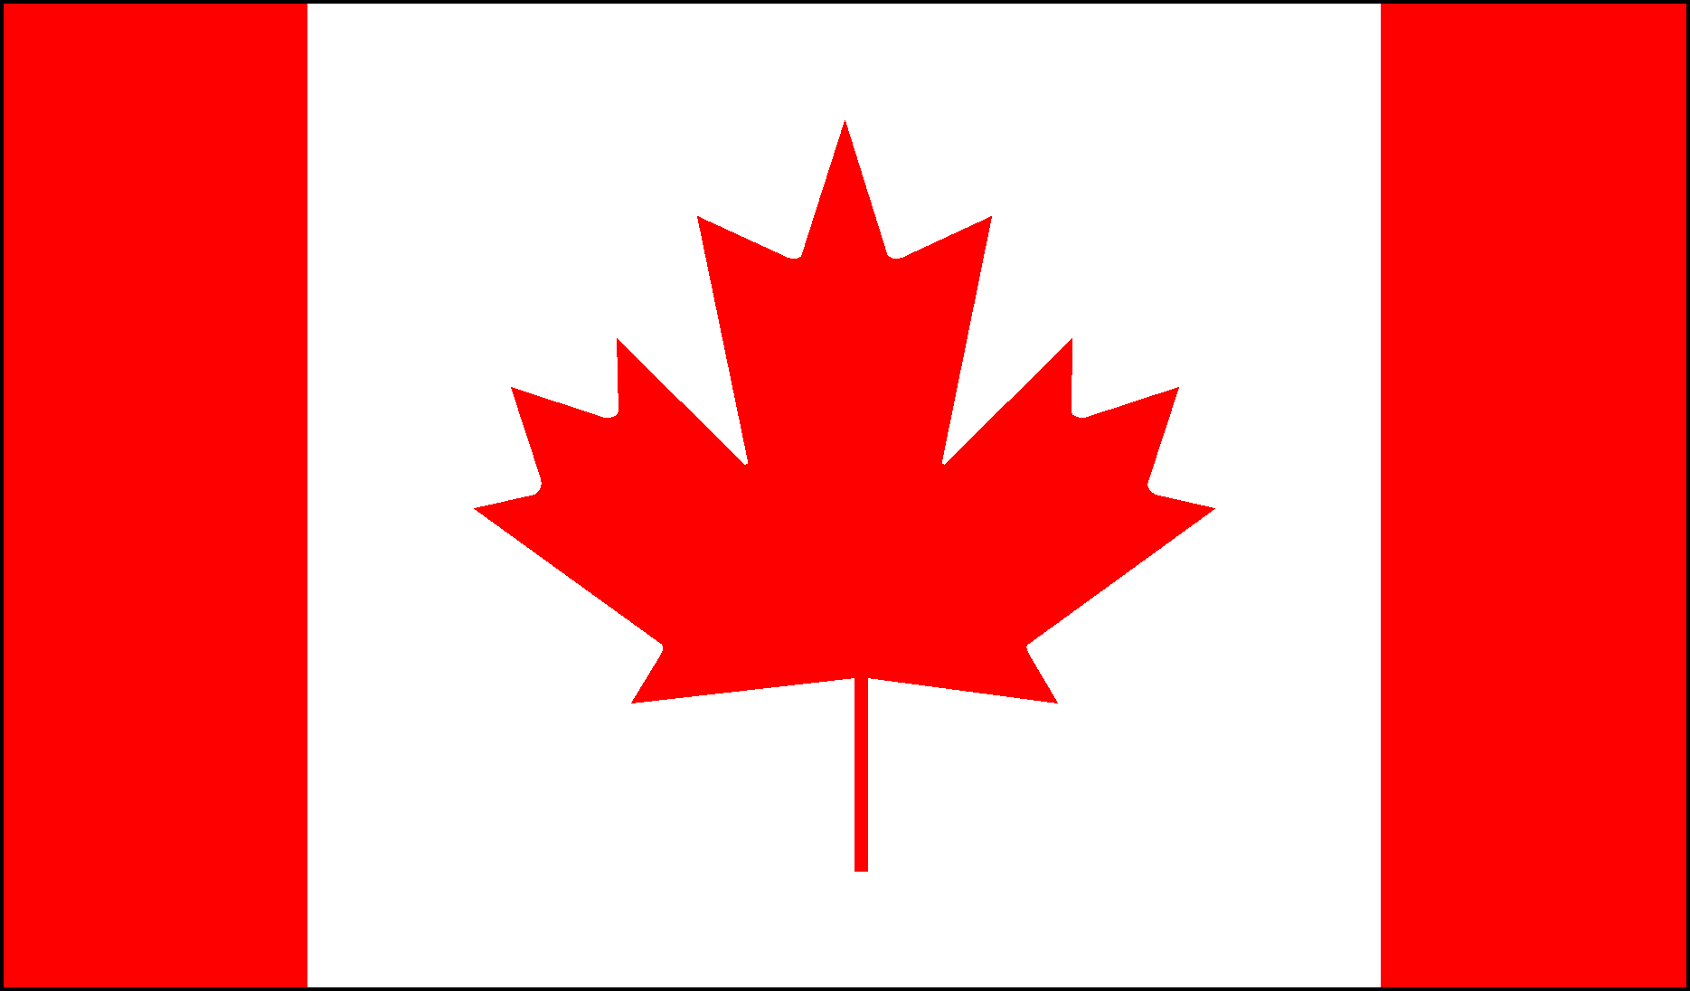
f) | g) | h) | i) | j)
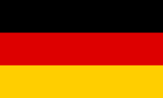 | 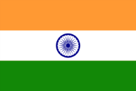 | 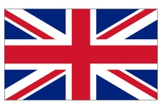 | 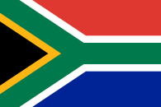 | 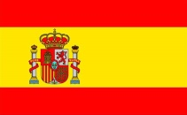
k) | l) | m) | n) | o)

Japan | France | USA | Canada | UK
India | Australia | South Africa | Germany | Mexico
Brazil | South Korea | China | Greece | Spain

- Famous Landmarks : Match the landmarks with the country.
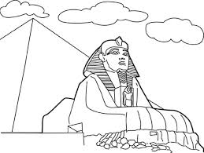 | 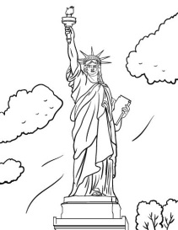 | 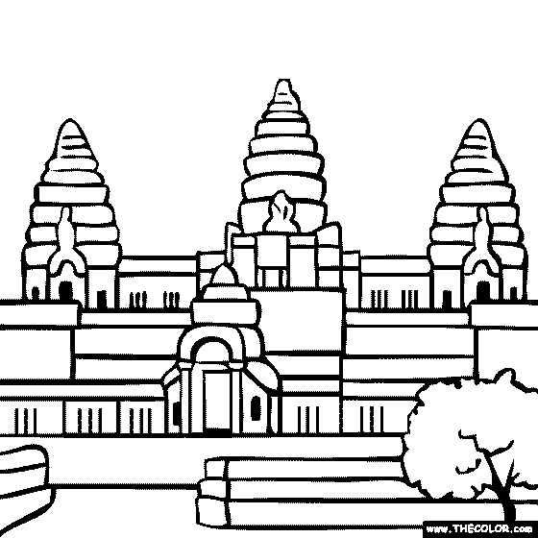 | 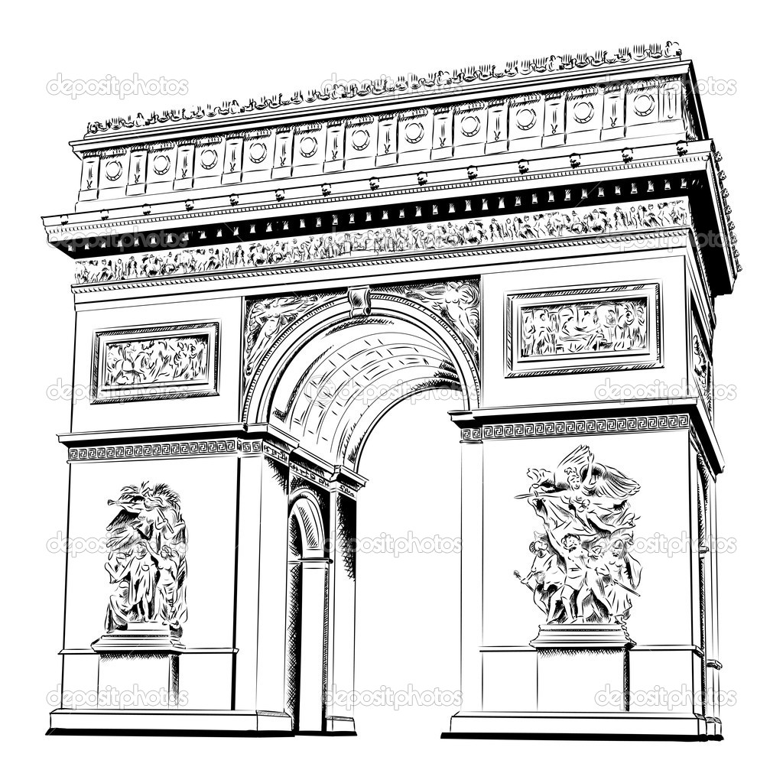
a) | b) | c) | d)
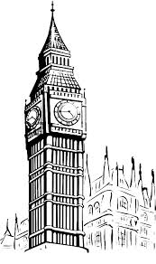 | 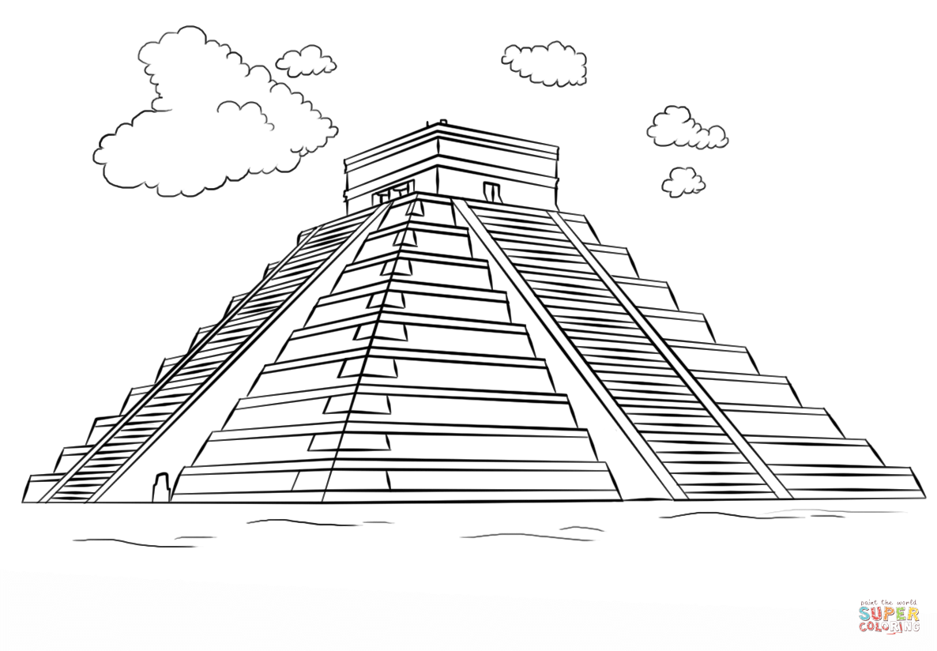 | 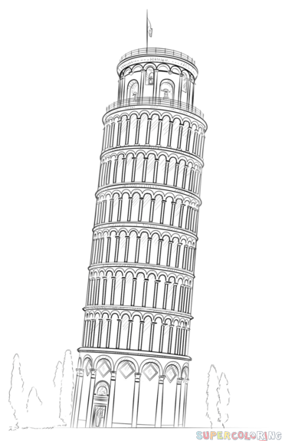 | 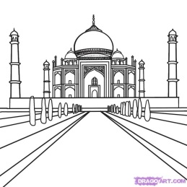
e) | f) | g) | h)
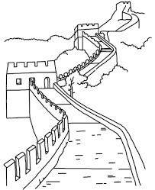 | 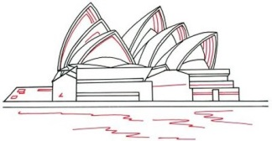 | 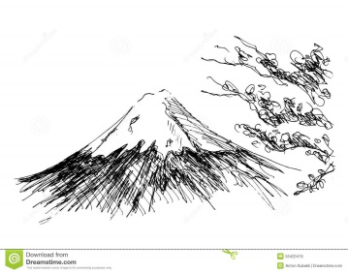 | 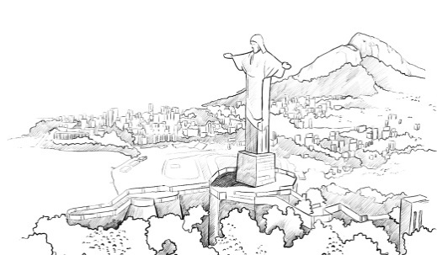
i) | j) | k) | l)

USA | Egypt | India | UK | Japan | Australia
Cambodia | China | France | Mexico | Italy | Brazil

- Capital Cities : Fill in the missing letters
- Japan = T _ K Y _
- UK = L _ N D _ N
- France = P _ R _ S
- Germany = B _ R L _ N
- Italy = R _ M _

- USA = W _ S H _ N G T _ N DC
- Australia = C _ N B _ R R _
- China = B _ _ J _ N G
- Egypt = C _ _ R _
- India = N _ W D _ H L _

- Continents : Put the countries into the correct continent
Africa | Europe | North America | South America | Asia

China Brazil India Canada France Egypt Germany
Japan UK Kenya Mexico Spain Peru South Korea
USA Norway South Africa Nigeria Vietnam Argentina

- Unjumble the letters to answer the questions
- In Italy they like to eat __________________________ . ( E P A T S G H T I )
- In Canada the speak English and __________________ . ( C H E F R N )
- In Australia you can see many ____________________ . ( G O O N A K R A S )
- The country with the most people is _______________ . ( N A I C H )
- Egypt is famous for _____________________________ . ( P M R A S Y I D )

