Match words and pictures
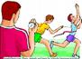
Art
1

3

2

4


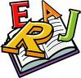
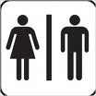
cafeteria
1333

calculator

classroom
5

6

7

8

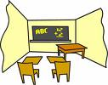
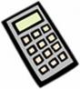
desk
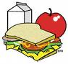
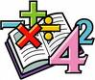
English

Music
laboratory (lab)
PE (Sport)
packed lunch
library
principal
Math(s)
school
school bag
teacher
Science
toilets

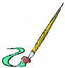
9

11

12

10


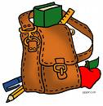
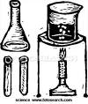

13

14

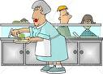
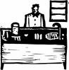
15

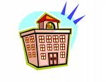

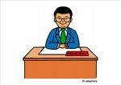

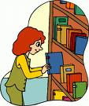
17

18

16

Write the words (more than 1 answer possible)

- Big boss of the school : ……………………………………………………………………
- You can read or borrow books here : ……………………………………………………………………
- You add, subtract, divide and multiply : ……………………………………………………………………
- You play an instrument : ……………………………………………………………………

