Match words and pictures: What’s the weather like? It’s …
1

2

3


autumn (fall)
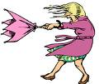

cloudy

foggy
6

freezing
4

5


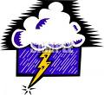

hot

rainy

snowy
8


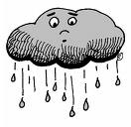
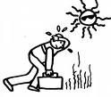
7

9

spring

summer
stormy
1

sunny
windy

12




10

11

13

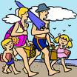

winter

Write the words

- What comes after winter : ……………………………………………………
- You need an umbrella when it’s : ……………………………………………………
- Dog are often afraid when it’s : ……………………………………………………
- When leaves turn red it’s : ……………………………………………………

