Find 12 pets in the wordsearch and unscramble the words under the pictures.

T U R L W Q Y H W E O S P T E F G O D Q
T A K H H X S B X L G N U V O U N V M Z
R P C U J R K R E T S M A H I R H L W T
S C M O Q Q J V J R D A O N D B R X C J
C V K L D W V P S U J C E Y T N Z A N X
E O J X M O R I Q T I A C I K U D D P V
W Y S J U Z G R Q P P T B X K E M L W B
M G O R F Y O H K I X B K X N V E E F N
B A U Y S M D A G L A Q S Q X T B Q X X
L J H C Z N X K X R J P T T M O E R L U
M I B B V B P M U O E A T I K V Z V H Z
B O D C X R T K U V Z P P P K L A R J B
V N U E Y N N C N B Q A O Z Z X H T F B
A Z L S G U W P V I X X B N Z X I I B I
O T H V E R O S F N Z Q D E G N S M C R
B A F K U B R R I W H X P M P H W L D D
K I L V I X C B J S Y W B R J B L V F U
R B A G S V I U F M D Z S Q X L G P N H
W N Q J Q L H K Y R R O U I H G Q L E A
G Z S P I D E R P Y A E U D H H D K B L

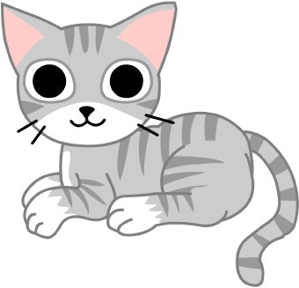 | 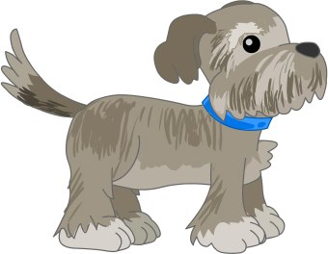 | 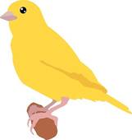 | 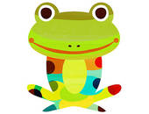
TAC – | ODG - | RBDI - | ORGF -
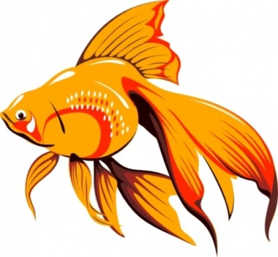 |  |  | 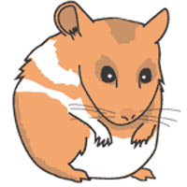
I S FH - | EUTTRL - | UEOMS - | SHATEMR -
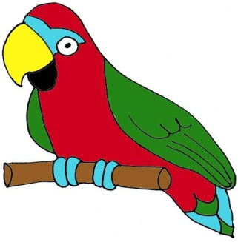 | 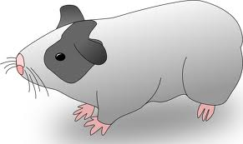 | 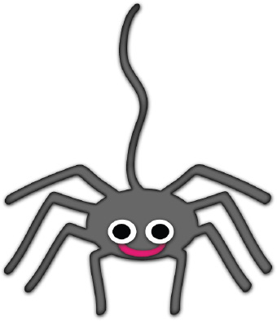 | 
TPAROR - | EUGINA GPI – | DPIESR - | BABIRT -

